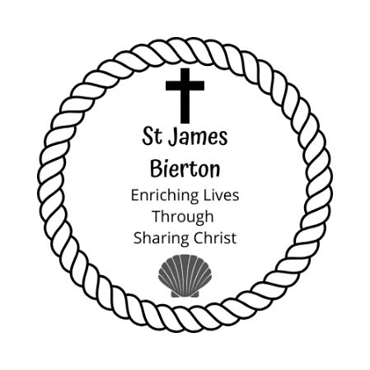

**Thought for the Week**

Saints,

It seems that we are turning the corner in our new way of living our lives but with the knowledge that this can be easily taken away, if things take a turn for the worse.

The world is fragile and that is the reality of life at the moment, but this Sunday’s bible passage promises certainty, which is such a great comfort. Having and knowing certainty in the midst of life, especially when it seems so uncertain is a great comfort and that is how the word ‘Helper’ is translated as ‘Comforter’.

Even though what is happening in the world and in our lives will still continue to happen, we have an unimaginable power inside of us because God dwells in us. The power of the Spirit gives us an extra kind of strength to cope with things that would usually be too much for us to cope with.

Why? Because God loves us and He is there for us not just in the happy times but in all of our sad times, in times of distress and despair. I hope that this brings you comfort, it certainly does for me.

Stay safe and many blessings, Rev Dan.

Pew News

**Sunday 17th May – 6th Sunday of Easter**

**Readings:** Acts 17:22-31; Psalm 66:7-end, 1 Peter 3:13-end;

**John 14:15-21**

**What’s on this week**

Every day we will pray at 11am, the Archbishop of Canterbury and the Bishop of Oxford have asked us to say Psalm 23 and to pray

the Lord’s Prayer as part of our prayers.

**Sunday 24th May – 7th Sunday of Easter**

**Readings:** Acts 1:6-14; Psalm 68:1-10, 1 Peter 4:12-14, 5:6-11;

**John 17:1-11**

Revd Dan will be recording a Said Communion, a Sung Eucharist and a Family Service every week, these will be available to watch every Sunday on his YouTube channel until the Archbishops allow us to return to worship in the church. He is also recording a daily reflection during this difficult time.

The link to his channel is www.youtube.com/monoingles

**Collect for the 6th Sunday of Easter**

Almighty God, God our redeemer, you have delivered us from the power of darkness and brought us into the kingdom of your Son: grant, that as by his death he has called us to life, so by his continual presence in us he may raise us to eternal joy; through Jesus Christ your Son our Lord, who is alive and reigns with you, in the unity of the Holy Spirit, one God, now and for ever. **Amen.**

**Prayers**

**Monday** – For all the frontline staff and their families.

**Tuesday** – For all the people in our parish as they adjust to a new way of living.

**Wednesday** – For St. James church and that it may be open soon to serve those in need.

**Thursday** – For the government as they continue to make key decisions.

**Friday** – For our parish schools and all who work in or attend them.

**Saturday** – For the economy and all who are affected by the negative impact of the virus.

**Sunday** – For our deanery, archdeaconary, diocese and bishops.

**News and Notices**

* St James the Great church remains closed but I (Rev Dan) am able to enter the church to pray and to record the Sunday services. It is great to be back in the church and it is the first step of a three-step process to return to us all coming back to worship together.
* If any of you have birthdays or prayer requests please send them to me (Rev. Dan) or Christine, so that they can be included in the pew sheet.
* Patrick Fairfield’s funeral will be conducted by Rev Dan this Friday, please remember his family in your prayers.
* How are the sunflowers coming along? I think mine never ever got out of the ground!

**Church Family Prayers & Requests**

* Please pray for Keiran and Becky – Deirdre
* Please pray for Jamie from our parish whose grandfather died of Covid-19. Jamie joined us for the live family service.
* Please remember Pam Fairfield in your prayers after the death of Patrick.

**Vicar:** Revd**.** Dan Beesley

**Tel:** 07872 160247

***Clergy days off:*** *Thursday - Saturday*

**Churchwardens:** Christine Tompkins 422087; Jan Sailes 426077

***For general enquiries:* Email:** greatjamesenquiries@gmail.com

**www.stjamesbiertonandhulcott.com**