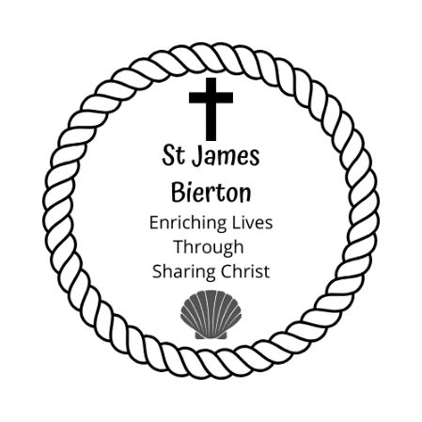

**Thought for the Week**

Saints,

I keep hearing the phrase ‘a new kind of normal’ indicating that what life will be like for us in the future, will be very different from what it is now and it is something that we will have to get used to.

I am reminded of when the Israelites were taken to Babylon during the Exile. They were uprooted from everything that they had known and were now in a very different place and Jeremiah wrote to them and said ‘Also, seek the peace and prosperity of the city to which I have carried you into exile. Pray to the Lord for it, because if it prospers, you too will prosper.’ (29:7).

In their ‘new world’ God is calling them to seek the peace and prosperity of it and if it does prosper then they will prosper. This is now the calling that we have as a church, to seek the peace and the prosperity of the parish.

The task is going to be a great one but luckily we have a greater God!

Stay safe and many blessings, Rev Dan.

Pew News

**Sunday 24th May – 7th Sunday of Easter**

**Readings:** Acts 1:6-14; Psalm 68:1-10, 1 Peter 4:12-14, 5:6-11;

**John 17:1-11**

**What’s on this week**

Every day we will pray at 11am, the Archbishop of Canterbury and the Bishop of Oxford have asked us to say Psalm 23 and to pray

the Lord’s Prayer as part of our prayers.

**Sunday 31th May – Pentecost**

**Readings:** Acts 2:1-21; Psalm 104:26-36, 1 Corinthians 12:3-13;

**John 20:9-23**

Revd Dan will be recording a Said Communion, a Sung Eucharist and a Family Service every week, these will be available to watch every Sunday on his YouTube channel until the Archbishops allow us to return to worship in the church. He is also recording a daily reflection during this difficult time.

The link to his channel is www.youtube.com/monoingles

**Collect for the 7th Sunday of Easter**

O God the king of glory, you have exalted your only Son Jesus Christ with great triumph to your kingdom in heaven: we beseech you, leave us not comfortless, but send your Holy Spirit to strengthen us and exalt us to the place where our Saviour Christ is gone before, who is alive and reigns with you, in the unity of the Holy Spirit, one God, now and for ever. **Amen.**

**Prayers**

**Monday** – For all the frontline staff and their families.

**Tuesday** – For all the people in our parish who are worried about the next phase of the exit strategy.

**Wednesday** – For St. James church and that it may be open fully to serve those in need.

**Thursday** – For the government as they continue to make key decisions.

**Friday** – For our parish schools and all who work in or attend them.

**Saturday** – For the economy and all who have lost their jobs.

**Sunday** – For our church family.

**News and Notices**

* St James the Great church remains closed but I (Rev Dan) am able to enter the church to pray and to record the Sunday services.
* Congratulations to Janet’s Mum and Paul’s Nan, Violet who celebrated her 100th Birthday last Saturday. Congratulations from HM the Queen arrived on Violet’s actual birthday which was a lovely surprise and family, friends and neighbours went and sang Happy Birthday at a “social distance”.
* Thank you to all those who continue to give financially to St James on a regular monthly basis and to those who have recently so very kindly sent us cheques. We greatly appreciate your financial support. Although in this time of lockdown some of our expenses have reduced, we still have to pay on-going costs such as insurance and Parish Share. For those who would like to support the ministry of St James, you can contribute by Bank Transfer:

Account Number: 00300341 Sort code: 309038 or by sending a cheque payable to St James Church, Bierton to:

The Churchwardens, c/o the Vicarage, 5 St James Way, Bierton, Bucks. HP22 5ED. Thank you for your consideration, particularly at this difficult time.

**Vicar:** Revd**.** Dan Beesley

**Tel:** 07872 160247

***Clergy days off:*** *Thursday - Saturday*

**Churchwardens:** Christine Tompkins 422087; Jan Sailes 426077

***For general enquiries:* Email:** greatjamesenquiries@gmail.com

**www.stjamesbiertonandhulcott.com**